Python

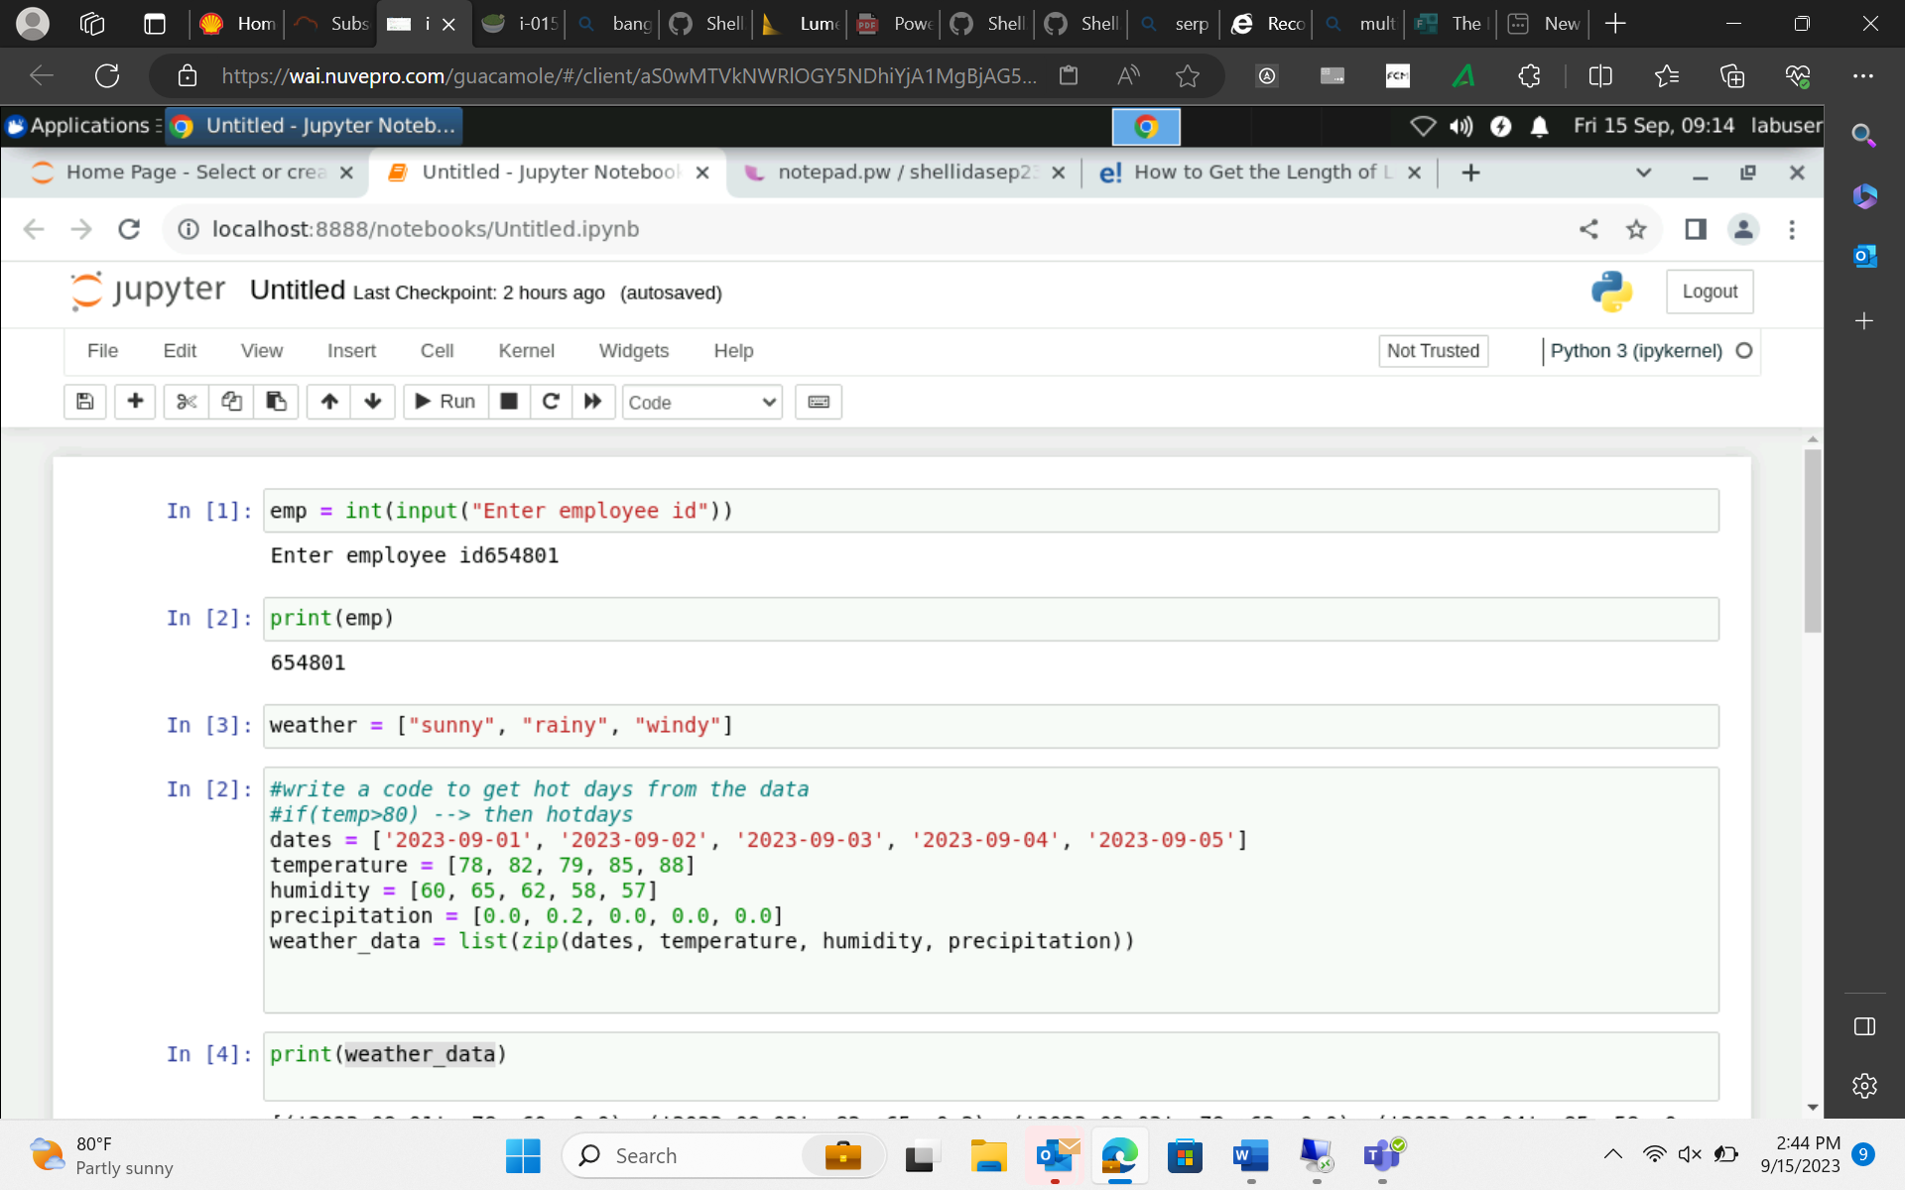

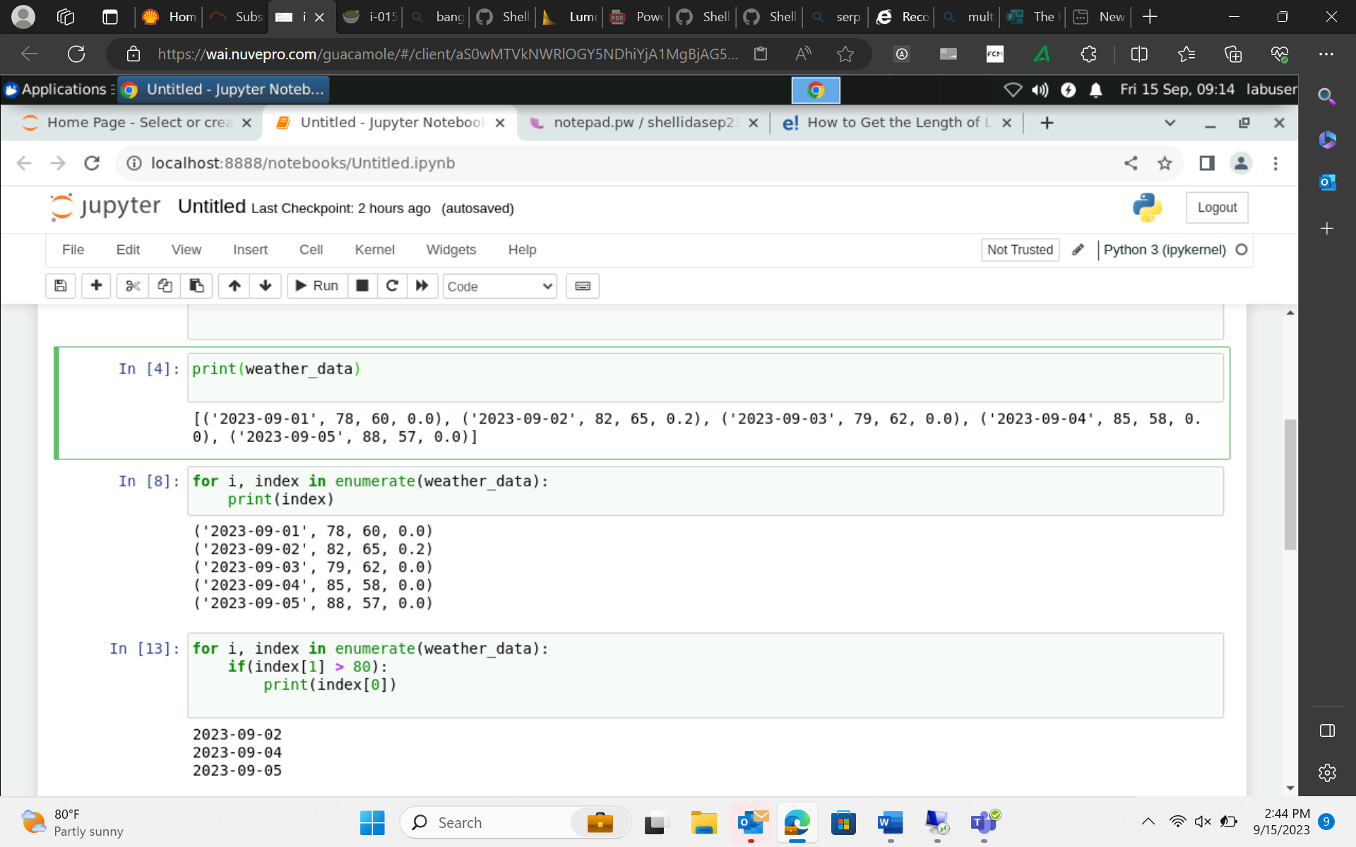

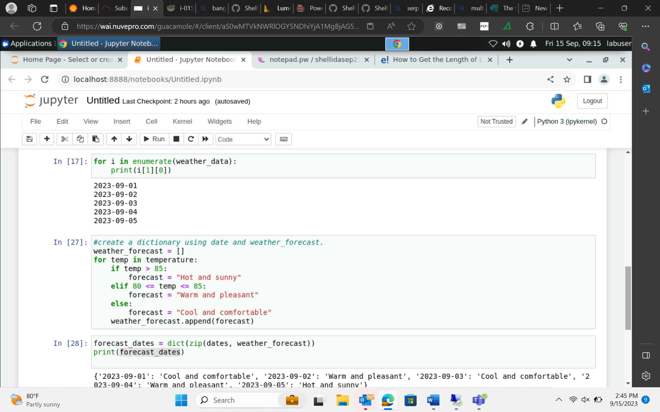

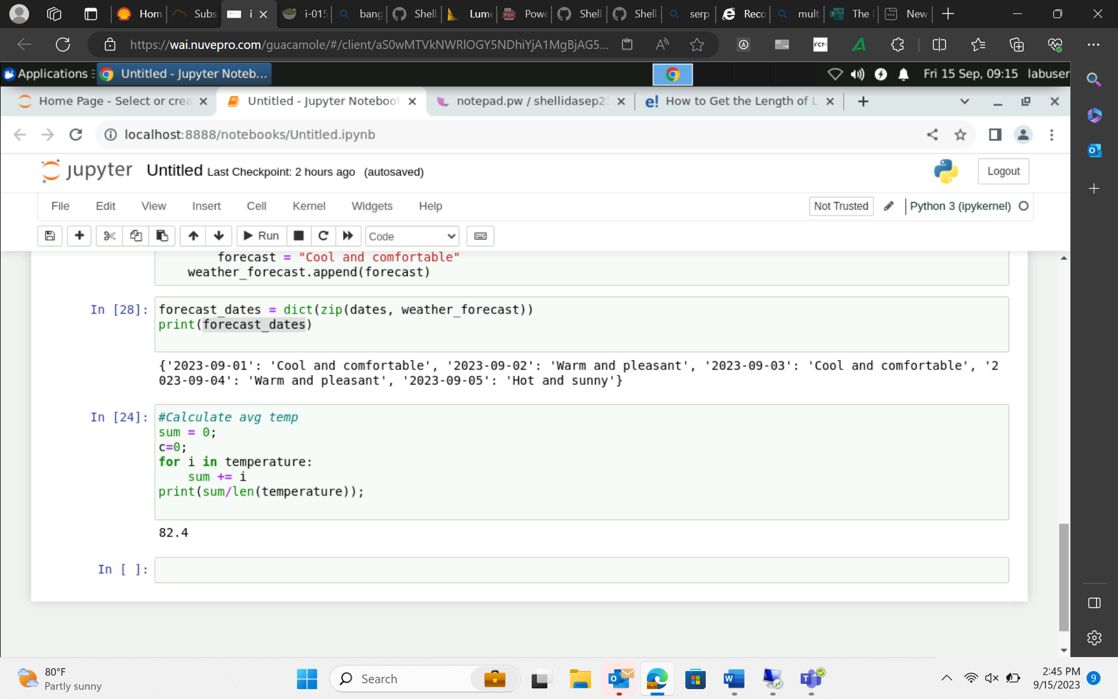

Data engineering: streaming data

Event Time

Ingestion Time

Process time

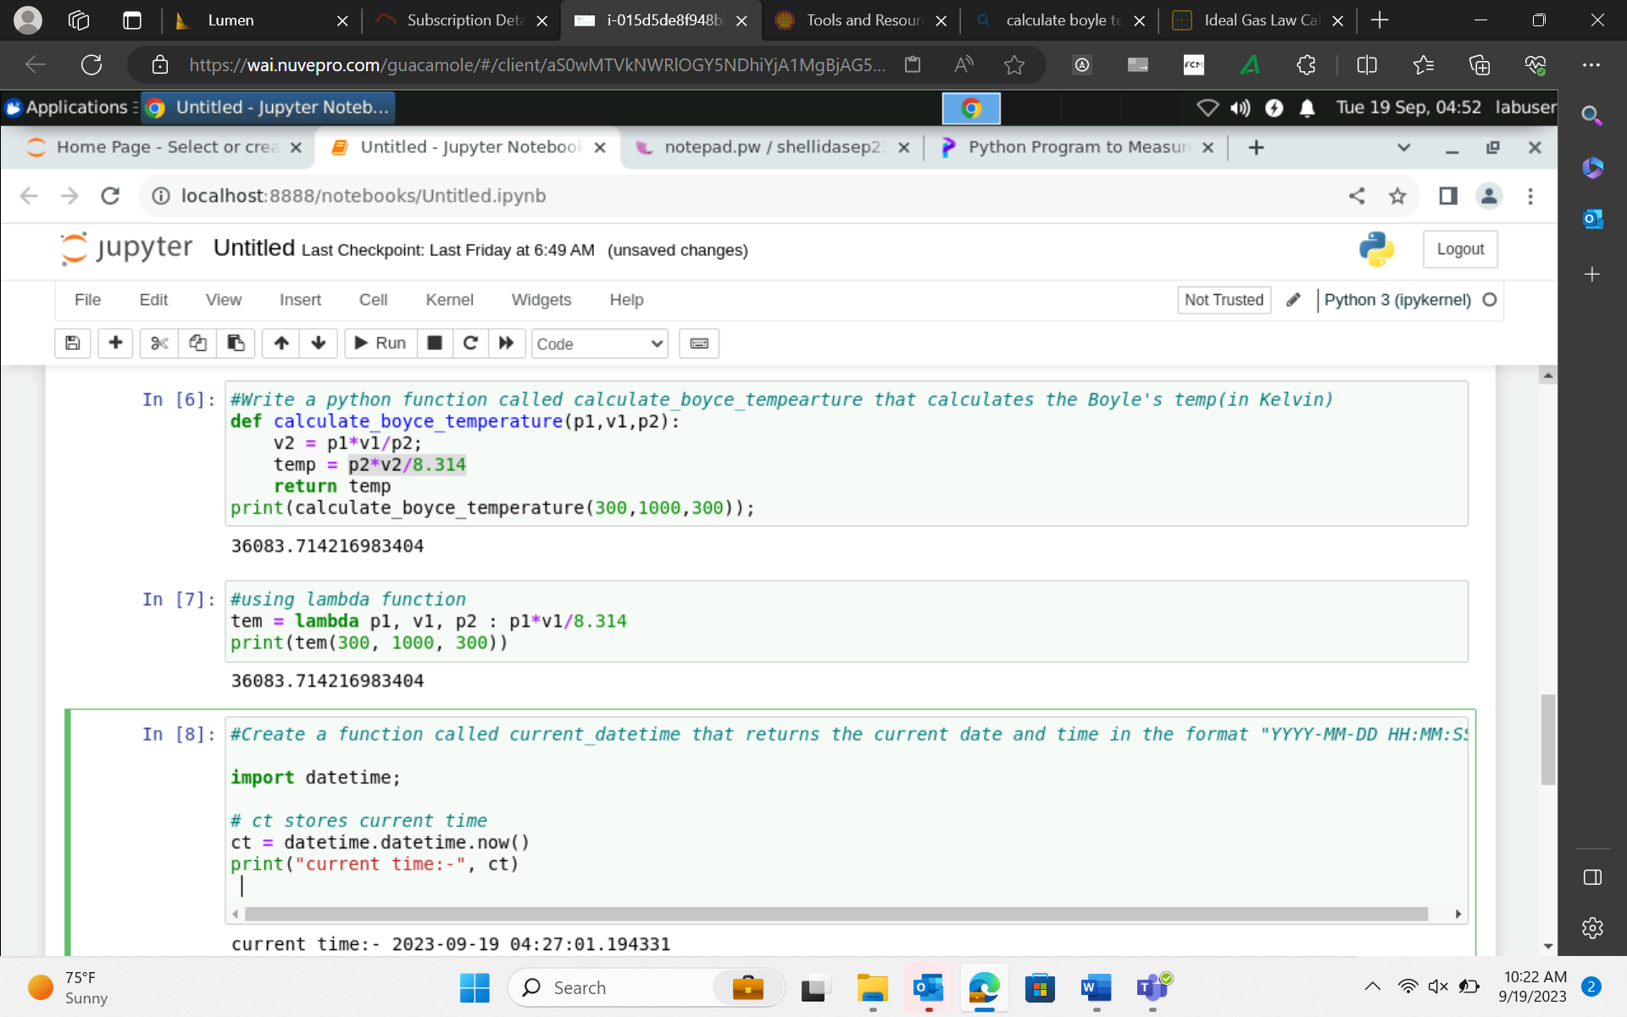

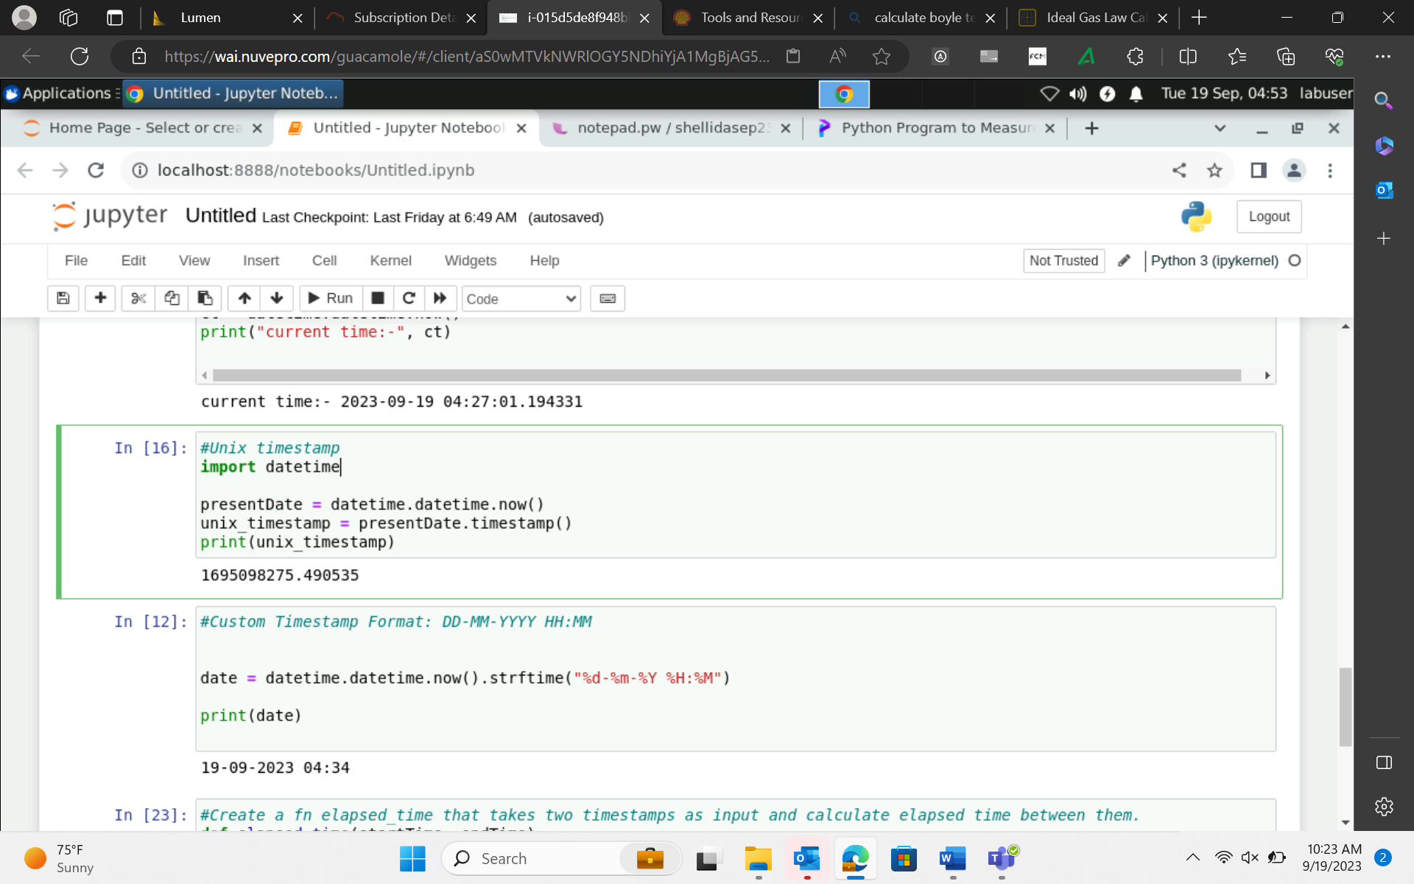

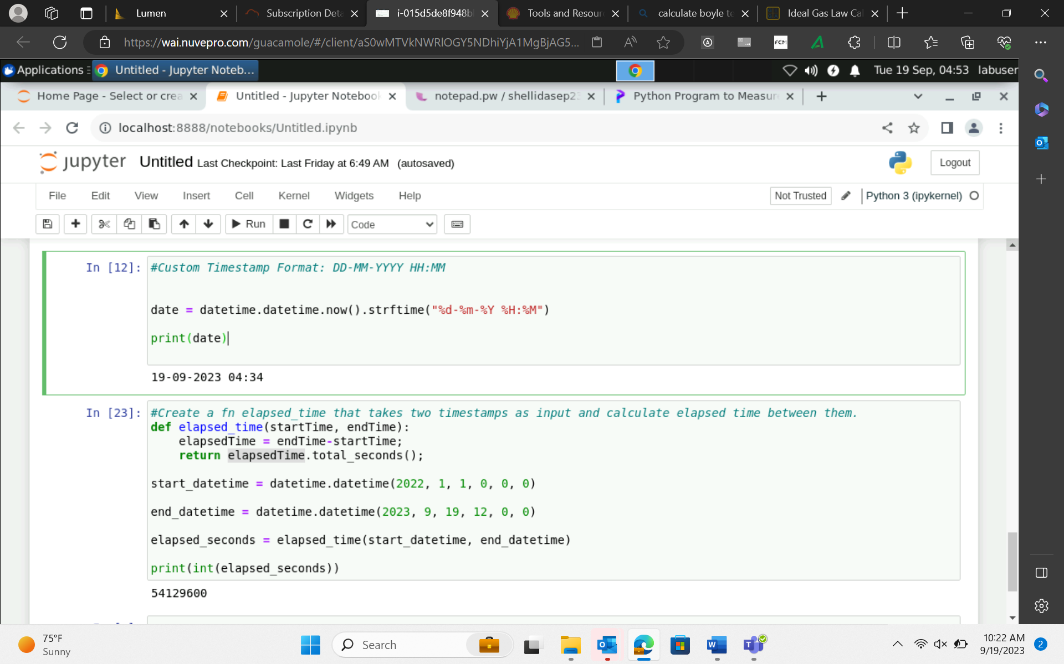

Arguments :

Positional Arguments -> def fun(a,b,c) 🡪 same position 🡪 order is very important

Fun(1,2,3)

Keyword Arguments 🡪 def fun(a=1, b=2, c=3)

Default arguments 🡪 if value of third parameter not provided then replace with the default value

Def fun(a=5,b,c)

Fun(a,6,7) or fun(b,c)

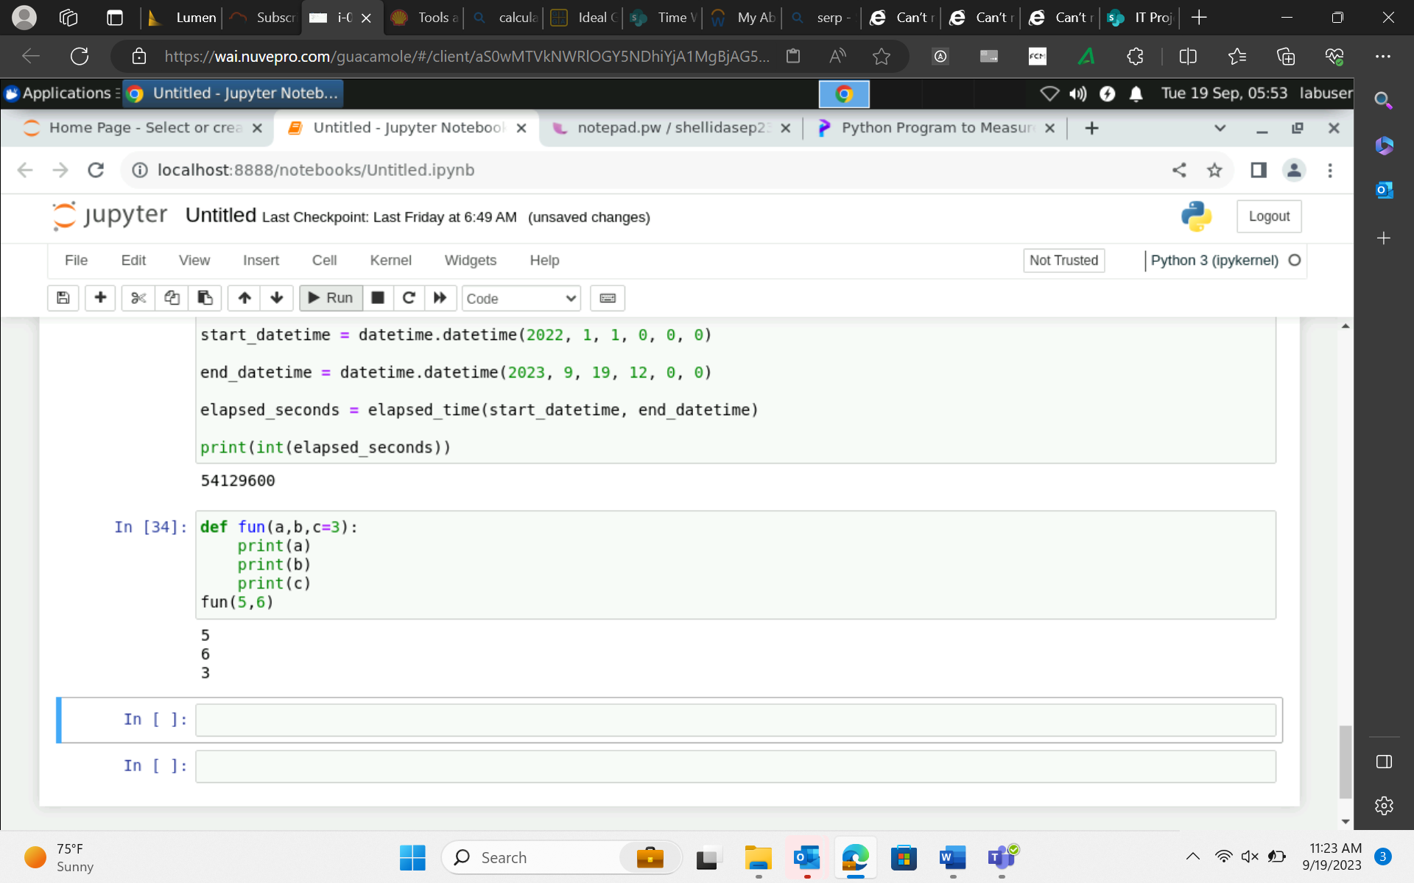

Variable length arguments

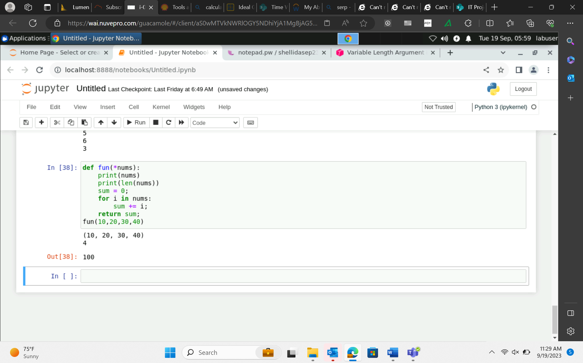

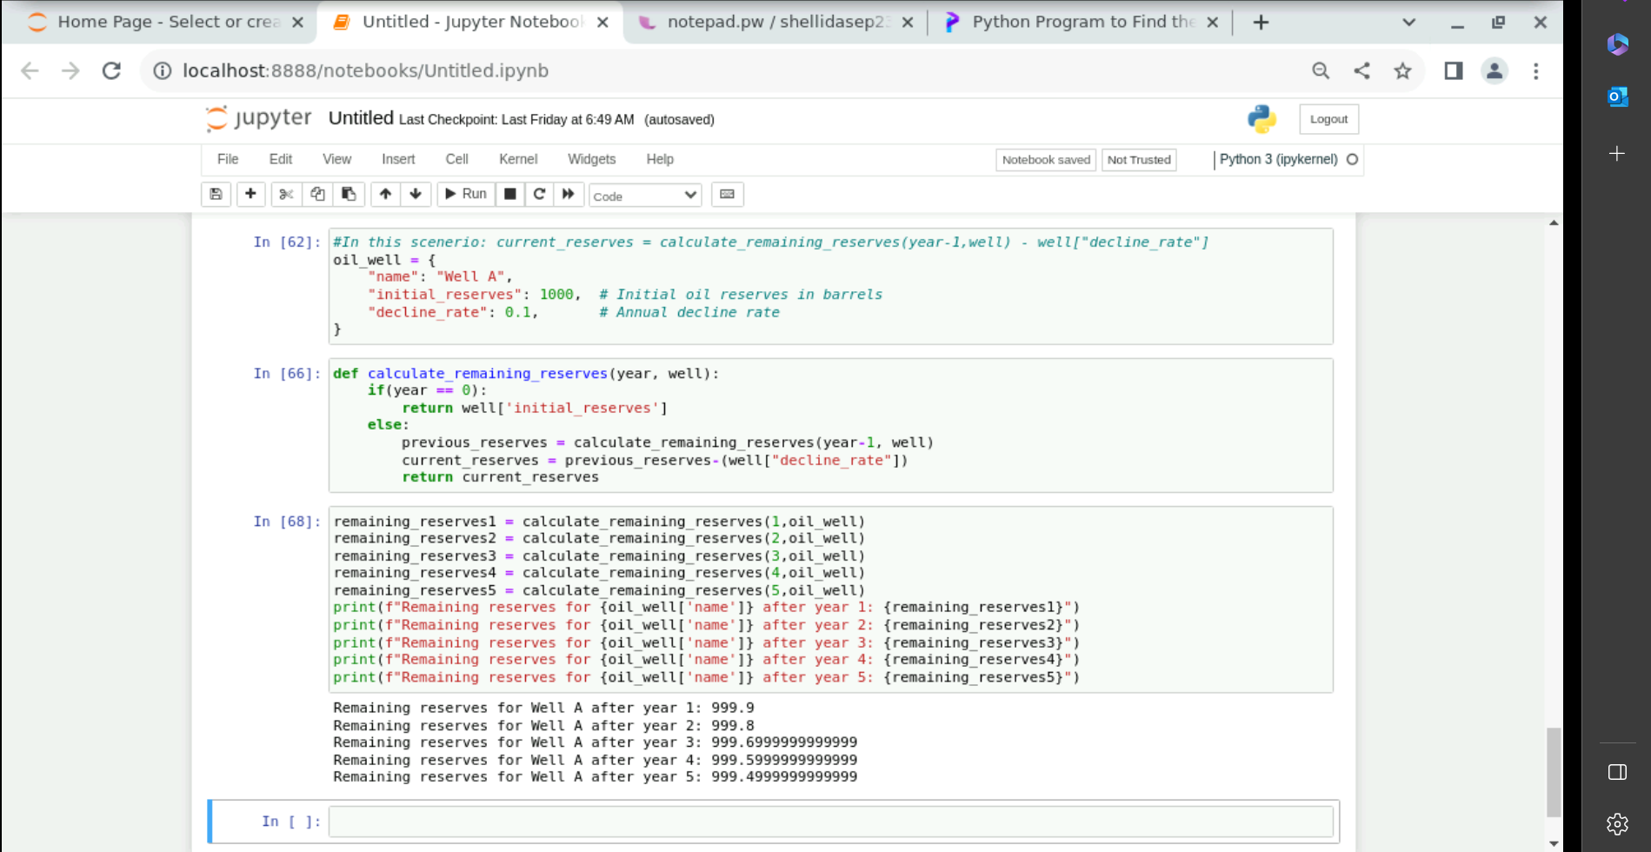

Decorator function python

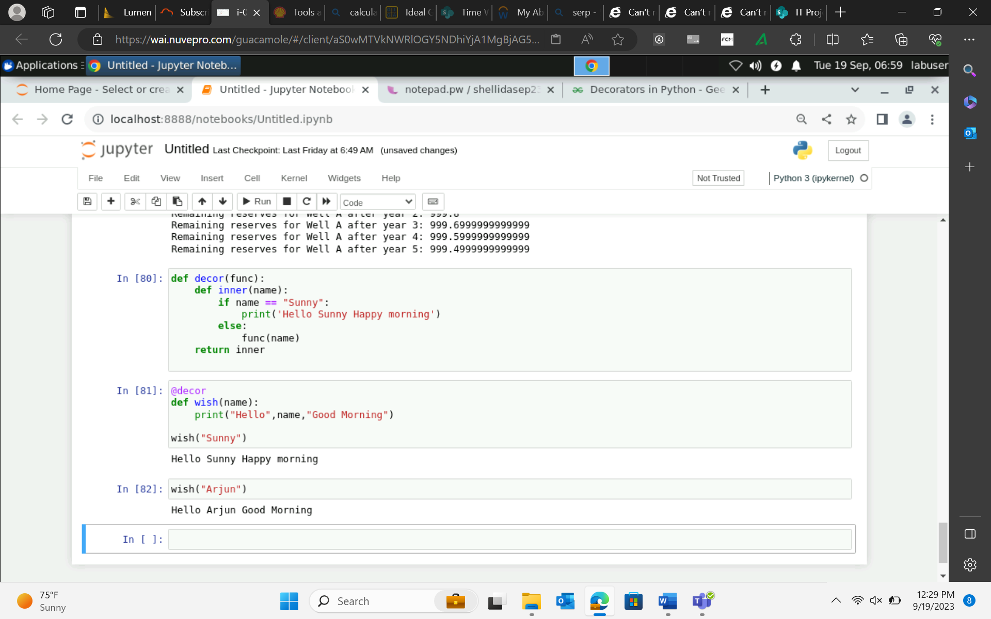

Scenario: You are building a Power BI report for a sales team, and you need to calculate the total sales amount for each product. Should you use a calculated column or a measure for this task, and why?

Measure is used – performing aggregations

Scenario: You have a dataset containing a "Sales" column and a "Discount" column. You want to calculate the discounted sales amount for each row. Should you use a calculated column or a measure for this calculation, and why?

Calculated column – row level

" You have a dataset containing information about sales transactions, including a ""Sales"" table and a ""Products"" table. You want to count the number of products with a price greater than $50.

Which DAX function would you use to count the number of products with a price greater than $50 in this scenario?"

Sequence generator

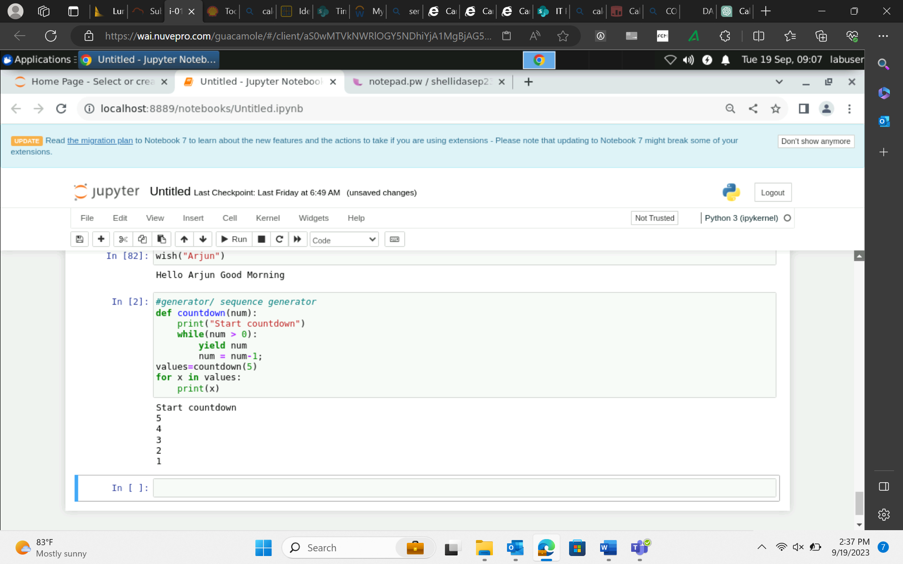

class Route:

def __init__(self, route_id, route_name, capacity, cost_per_km):

self.route_id = route_id

self.route_name = route_name

self.capacity = capacity

self.cost_per_km = cost_per_km

self.capacity_available = capacity

class Shipment:

def __init__(self, shipment_id, product_type, quantity, distance_km):

self.shipment_id = shipment_id

self.product_type = product_type

self.quantity = quantity

self.distance_km = distance_km

self.cost = 0 # Placeholder for calculated cost

class DistributionCenter:

def __init__(self, center_id, center_name, location):

self.center_id = center_id

self.center_name = center_name

self.location = location

class LogisticsManager:

def __init__(self, routes, shipments, distribution_centers):

self.routes = [Route(**r) for r in routes]

self.shipments = [Shipment(**s) for s in shipments]

self.distribution_centers = [DistributionCenter(**dc) for dc in distribution_centers]

def calculate_transport_cost(self, route, shipment):

cost = route.cost_per_km * shipment.distance_km

return cost

def check_route_availability(self, route, shipment):

if route.capacity_available >= shipment.quantity:

return True

else:

return False

def optimize_shipments(self):

for shipment in self.shipments:

for route in self.routes:

if self.check_route_availability(route, shipment):

cost = self.calculate_transport_cost(route, shipment)

if not shipment.cost or cost < shipment.cost:

shipment.cost = cost

shipment.selected_route = route

def display_shipment_schedule(self):

for shipment in self.shipments:

print(f"Shipment ID {shipment.shipment_id}:")

print(f" Product Type: {shipment.product_type}")

print(f" Quantity: {shipment.quantity}")

print(f" Distance (km): {shipment.distance_km}")

print(f" Selected Route: {shipment.selected_route.route_name}")

print(f" Transportation Cost: {shipment.cost:.2f}")

print("=" * 40)

# Sample data

routes_data = [

{"route_id": 1, "route_name": "Route A", "capacity": 100, "cost_per_km": 2.5},

{"route_id": 2, "route_name": "Route B", "capacity": 150, "cost_per_km": 3.0},

{"route_id": 3, "route_name": "Route C", "capacity": 200, "cost_per_km": 2.0},

]

shipments_data = [

{"shipment_id": 101, "product_type": "Crude Oil", "quantity": 50, "distance_km": 200},

{"shipment_id": 102, "product_type": "Natural Gas", "quantity": 1000, "distance_km": 300},

{"shipment_id": 103, "product_type": "Crude Oil", "quantity": 80, "distance_km": 150},

{"shipment_id": 104, "product_type": "Liquefied Natural Gas (LNG)", "quantity": 500, "distance_km": 250},

]

centers_data = [

{"center_id": 1, "center_name": "Center X", "location": "City A"},

{"center_id": 2, "center_name": "Center Y", "location": "City B"},

{"center_id": 3, "center_name": "Center Z", "location": "City C"},

]

# Create and manage logistics

logistics = LogisticsManager(routes_data, shipments_data, centers_data)

logistics.optimize_shipments()

logistics.display_shipment_schedule()

# Sample data for transportation routes

routes = [

{"route_id": 1, "route_name": "Route A", "capacity": 100, "cost_per_km": 2.5},

{"route_id": 2, "route_name": "Route B", "capacity": 150, "cost_per_km": 3.0},

{"route_id": 3, "route_name": "Route C", "capacity": 200, "cost_per_km": 2.0},

]

# Sample data for product shipments

shipments = [

{"shipment_id": 101, "product_type": "Crude Oil", "quantity": 50, "distance_km": 200},

{"shipment_id": 102, "product_type": "Natural Gas", "quantity": 1000, "distance_km": 300},

{"shipment_id": 103, "product_type": "Crude Oil", "quantity": 80, "distance_km": 150},

{"shipment_id": 104, "product_type": "Liquefied Natural Gas (LNG)", "quantity": 500, "distance_km": 250},

]

# Sample data for distribution centers

distribution_centers = [

{"center_id": 1, "center_name": "Center X", "location": "City A"},

{"center_id": 2, "center_name": "Center Y", "location": "City B"},

{"center_id": 3, "center_name": "Center Z", "location": "City C"},

]

# Sample data for available routes and their capacities

available_routes = [

{"route_id": 1, "capacity_available": 80},

{"route_id": 2, "capacity_available": 120},

{"route_id": 3, "capacity_available": 180},

]

# Sample data for logging shipment activities

shipment_logs = []

# Sample data for product scheduling (for recursive function)

product_quantities = {

"Crude Oil": 200,

"Natural Gas": 800,

"Liquefied Natural Gas (LNG)": 300,

}

pd.read_csv(filepath_or_buffer, sep=’ ,’ , header=’infer’, index_col=None, usecols=None, engine=None, skiprows=None, nrows=None)

Parameters:

filepath_or_buffer: Location of the csv file. It accepts any string path or URL of the file.

sep: It stands for separator, default is ‘, ‘.

header: It accepts int, a list of int, row numbers to use as the column names, and the start of the data. If no names are passed, i.e., header=None, then, it will display the first column as 0, the second as 1, and so on.

usecols: Retrieves only selected columns from the CSV file.

nrows: Number of rows to be displayed from the dataset.

index_col: If None, there are no index numbers displayed along with records.

skiprows: Skips passed rows in the new data frame.

Moviedf.head()